

**Conference**

**Treasurers’ Toolkit**

|  |  |  |  |
| --- | --- | --- | --- |
| **Version** | **Issued by** | **Date** | **Review Date** |
| 1 | Finance Department |  |  |

**Table of Contents**

###### Summary of Conference Treasurer’s Duties 3

###### Financial Team Key Contacts 4

###### Financial Delegation 6

###### Deposits 7

###### Deposit Notification Form 10

###### How to record donations 11

###### Expenses 14

###### Payment Voucher (Sample) 15

###### Gift Card Order Form 16

###### Petty Cash Procedures and Reimbursement Form 17-18

###### Financial Statements 19

###### Frequently Asked Questions 20

###### Additional Information 22

###### Postal Addresses…………………………………………………………………………………………………………….22

###### Finance KPIs / SLA’s 23

**APPENDIXES**

* 1. Regional Maps
  2. Conference Codes
  3. Retail Shops
  4. Conference Reports - Sample
  5. Chart of Accounts
  6. Blank copy of all forms(Both PDF and Excel Versions)

**Summary of Conference Treasurer’s Duties**

**Management of:**

* + Collection of all incoming Conference monies.
  + Write receipts for monies received using the official St Vincent De Paul receipt book that includes the ABN 91 161 127 340.
  + Bank all monies received as soon as possible using the Conference deposit book.
  + Complete Banking Deposit Notification form, email to [rsc@vinnies.org.au](mailto:rsc@vinnies.org.au)
  + Completed Receipt Books returned to Region Support Coordinator.
  + Send all Conference accounts with payment request forms to Accounts, via email where possible. (date stamp and file originals).
  + Manage Conference Petty Cash float/Petty Cash Card.
  + Manage Client Gift Card orders and Register (Woolworths, Coles, IGA, etc.,)
  + Report to Conference meeting:
    - For all money received (eg; income from secret collections, catholic paper sales, pious goods sales, donations etc.)
    - For all Conference accounts to be paid (eg; purchase of catholic papers, pious goods, food for clients, food for Christmas Hampers etc.).
    - For all expenditure (including on Client Care & Support and Operating expenses) since the last meeting.
  + Ensure that all moneys in and out are correctly recorded in the conference minutes.

**Finance Team Key Contacts - Financial Processing and Support**

**First point of contact would be your local Regional Support Coordinators.**





Barry Read

*West and North West Regions – Armidale, Bathurst and Wilcannia Forbes Central Councils*

*Phone: 02 7203 3616*

*Email: Barry.Read@vinnies.org.au*

Jonalyne Andersen

*North East Region – Lismore and Maitland Newcastle Central Councils*

*Phone: 02 7203 3619*

*Email: Jonalyne.Andersen@vinnies.org.au*



Murray Gray

*Metro Region – Sydney Arch Central Council*

*Phone: 02 7203 3618*

*Email: Murray.Gray@vinnies.org.au*

Cynthia Jayasooriya

*Metro Region – Great Western Sydney and Broken Bay Central Councils*

*Phone: 02 7203 3617*

*Email: Cynthia.Jayasooriya@vinnies.org.au*

**Vacant**

*South Region – Wagga Wagga and Wollongong Central Councils*

*(Current in the process of recruiting)*

Ewan Zhang

*Senior Analyst*

*Phone: 02 7203 3635*

*Email: Ewan.Zhang@vinnies.org.au*

Partner with MVRO and supporting the Regional Support Coordinators to provide financial planning, information, insights and advice to improve business operations. Finance lead for Management Reporter.



**Finance Team Key Contacts (cont)**



Janelle Fielding

*Manager, Shared Services*

*Phone: 02 7203 3615*

*Email: Janelle.Fielding@vinnies.org.au*

Oversee Accounts Payable and Receivable functions including retail shops banking and processing of donations.

Key Contact for Petty Cash Debit Cards

**For any accounts enquiries please call 02 7203 3610 or email** [**accounts.enquiries@vinnies.org.au**](mailto:accounts.enquiries@vinnies.org.au) **for one of our Shared Services Team member to assist you**



Jean-Baptiste (JB) Naudet

*Chief Financial Officer*

*Phone: 02 7203 3611*

*JB.Naudet@vinnies.org.au*

Lead the following functions: Finance, Property & Facilities, Procurement & Fleet and Payroll. Responsible to deliver on the following strategic priorities: financial sustainability, efficient and enabling systems and structures, and the property strategy.

Michael Hyde

*Group Finance, Plan & Analysis Manager –* ***Escalation point for budgeting and reporting matters***

*Phone: 02 7203 3612*

*Email: Michael.Hyde@vinnies.org.au*

Lead and develop the FP&A team to deliver financial planning, performance reporting, business analytics and insights as well as partnering with all directorates to identify financial improvement initiatives to achieve objectives of the directorate and strategic plans of the Society.

Roshan Naidu

*Group Financial Controller –* ***Escalation point for all transactional processing and financial accounting matters***

*Phone: 02 7203 3613*

*Email: Roshan.Naidu@vinnies.org.au*

Lead and develop the Financial Accounting and transactional processing team and working collaboratively with all directorates to deliver on Society wide accounting and finance functions including finance policies and procedures, transaction processing and support, transaction across regions, treasury services and financial reporting to external stakeholders in line with Directorate and Strategic plans of the Society.

Lisa Cheng

*Financial Accountant*

*Phone: 02 7203 3614*

*Email: Lisa.Cheng@vinnies.org.au*

Supporting the Group Financial Controller in all our Financial accounting functions including month end accounting and annual external audit program. Liaise and work collaboratively with members, staff and volunteers of the society

Key Contact for Promaster / Corporate Cards

1. **Deposits**

All banking should be completed promptly to reduce the risks associated with Members holding cash at home or at Conference Offices.

It is recommended that the collection of donations and appeals through cash and cheques are counted and signed by two people prior to depositing. Refer Cash Handling Policy.

Society funds should not be banked into parish bank accounts.

There are several options for depositing funds into the NSW Conference Bank account, these being:

Deposits over the Counter at CBA Branches or Australia Post Agencies

Quick Deposits at some CBA Branches.

ATM deposits (Only available at some Locations)

**Deposits over the Counter:**

Available at any CBA Branch or Australia Post agency using a Society Deposit book.

See below, Please note that Australia Post Deposit books are different to the CBA book as shown



Each Society deposit book which has a pre-printed unique number that identifies each Conference, this is the same as the Business Unit number used for Accounts payable and shown on Monthly P&L Finance Reports. This is listed on the deposit book as the Agent Number which appears on the Bank Statement for each deposit to identify the Conference depositing funds.

Ensure carbon paper is placed correctly in the book so that a legible copy of the deposit remains in the book after the original is taken by the bank.

New Deposit books are ordered by emailing your Regional Support Coordinator at [RSC@vinnies.org.au](mailto:RSC@vinnies.org.au), books are not to be ordered via your local Branch

**Quick Deposits (CBA Deposit Satchels/Bags)**

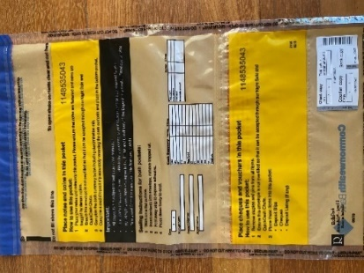These are only accepted by some CBA Branches, please check with your Local Branch Manager.

Instructions are on the plastic satchel on how to use insert cash (notes and coins, plus cheques. A deposit slip must also be completed with this type of deposit, with original inserted into pouch as listed in satchel.

Peel off the Client Copy from the Satchel bag (bottom right-hand side) and stick to book copy of deposit slip after completion.

These Deposit Satchels/bags can be ordered via your Region Support Coordinator.

**ATM deposits.**

Larger CBA Branches have reversible ATM’s (Auto Teller Machines) that accept deposits, it is best to seek assistance from the Staff at the Branch for assistance on how complete this Type of Deposit.

It is especially important that your Agent Number/ Business unit number be added to the description of the deposit, as per the above example of a deposit slip, the Code would be 49-447 in this case only. As the agent number appears on the Bank Statement for the account, so the RSC’s know which Conference the funds are to be allocated to.

**ATM Deposit Money using account details**

**Cardless Deposits with account details can be made up to $1000 per transaction for cash amounts and no more than twice per day per mobile phone number.**

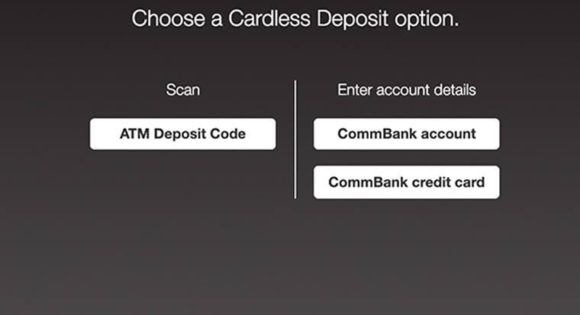

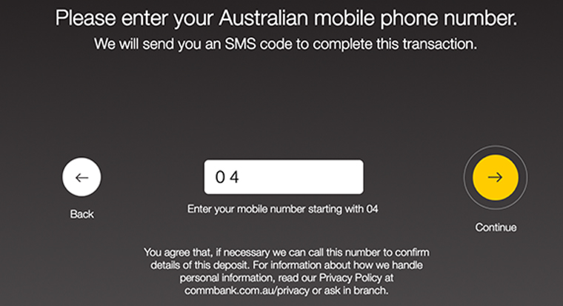

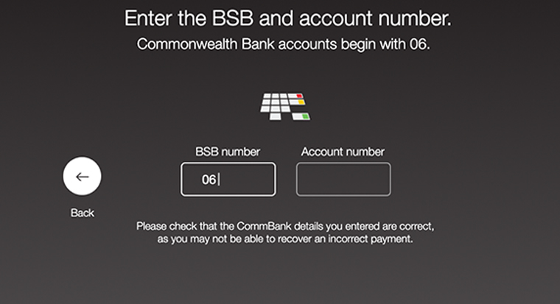

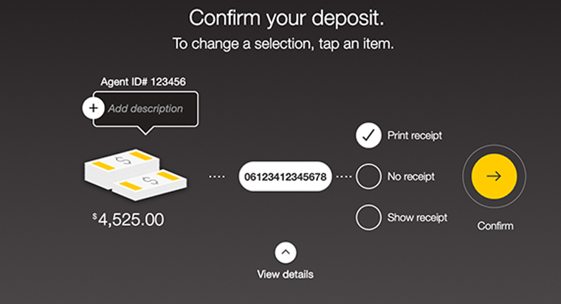

Funds can also be deposited in the ATM’s with use of a Deposit Card that some Conferences hold.

**Enter account details**. Enter account details - BSB & Account number to deposit money instantly.

BSB is 062-000 Account Number is 1988 9862

The ATM will produce a receipt of funds deposited including a scanned picture of any cheques, this receipt is to be sent to the Region Support Coordinator with the Deposit Notification form.

The Monthly Deposit Notification Form details should be recorded for each banking date, deposit amount and sources of the deposit e.g., from general donations, appeals, etc.,

Each month a Deposit Notification Form (**refer to page 10)** should be completed, signed, and emailed to your Regional Support Coordinator as soon as possible at the end of the month and no later than the 2nd working day of the next month**.** This is to ensure the money banked is correctly coded to the appropriate Business Unit and Chart of Account number.

It is recommended that this form be forwarded after each deposit or at least Weekly, as owing to time constraints with closure of the Finance month any deposit notifications for monies deposited in a particular month that are not received by finance within 2 working days of the following month will be coded to General Donations and adjusted the following month upon receipt of a Deposit notification form.

FORM to be emailed to: [rsc@vinnies.org.au](mailto:rsc@vinnies.org.au)

Or

Contact your Region’s RSC for Fax or Postal Address



**CONFERENCE DEPOSIT NOTIFICATION FORM**

To be received no later than the 2nd Working day of the new month

It is preferred that this form be completed and sent in at the time of Banking or Weekly.

|  |  |  |
| --- | --- | --- |
| Month of Deposit |  | |
| Region |  | |
| Conference Business Code & Name | **CODE:** | **NAME**: |

|  |  |  |  |  |  |  |
| --- | --- | --- | --- | --- | --- | --- |
| **Date of Deposit** | | ***WK1*** | ***WK2*** | ***WK3*** | ***WK4*** | ***WK5*** |
|  |  |  |  |  |
| Sale of Papers | 1240 |  |  |  |  |  |
| Sales of Pious/Christmas | 1245 |  |  |  |  |  |
| Winter Appeal | 1400 |  |  |  |  |  |
| Christmas Appeal | 1410 |  |  |  |  |  |
| Misc Appeals **\*** | 1440 |  |  |  |  |  |
| Bushfire Appeal | 1445 |  |  |  |  |  |
| General Donations | 1450 |  |  |  |  |  |
| Poor Box | 1460 |  |  |  |  |  |
| Bursary Collection | 1910 |  |  |  |  |  |
| Secret Collection | 1930 |  |  |  |  |  |
| Assist A Student | 1940 |  |  |  |  |  |
| Twinning | 1950 |  |  |  |  |  |
| Other (Please Specify) |  |  |  |  |  |  |
| Other (Please Specify) |  |  |  |  |  |  |
| **TOTA**L |  | **$** | **$** | **$** | **$** | **$** |

**\***Includes Drought and other Natural Disaster Appeals**\***

|  |  |
| --- | --- |
| Completed By: | Signed: |
| Position: | Contact Phone: |
| Date: |  |

1. **How to record donations**

All donations of $2 and over are tax deductible and a tax-deductible receipt should be issued for donations received. Donations are normally cash, cheques or credit cards and a valid tax-deductible receipt can only be issued after the donation is successfully processed.

Receipt books are ordered by emailing your Regional Support Coordinator at [RSC@vinnies.org.au](mailto:parradio@vinnies.org.au)

For compliance purposes the RSC must keep a record of receipt books issued as each receipt has a unique number.

###### Issuing Receipts

* + 1. **Issuing a tax-deductible receipt**
  1. The receipt book comes with three (3) copies – original white copy is to be given to the donor, yellow copy is to be attached with the Deposit Notification Form **(refer page 10)** and sent to CC office, and pink copy stays in the Receipt Book.
  2. For **Cash** donations, a tax-deductible receipt can be issued directly to the donor using the Receipt Book. Ensure name and address of the donor, amount donated, purpose of donation and name and signature of the person issuing the receipt are clearly written on the receipt.
  3. For **Cheque** donations, if requested, a tax-deductible receipt **will** be issued by your RSC after the transaction is successfully processed with banks or financial institutions. When receiving the cheque from the donor, please ask for their name, address & phone number to be written on the back of the cheque to enable a receipt to be sent if required.

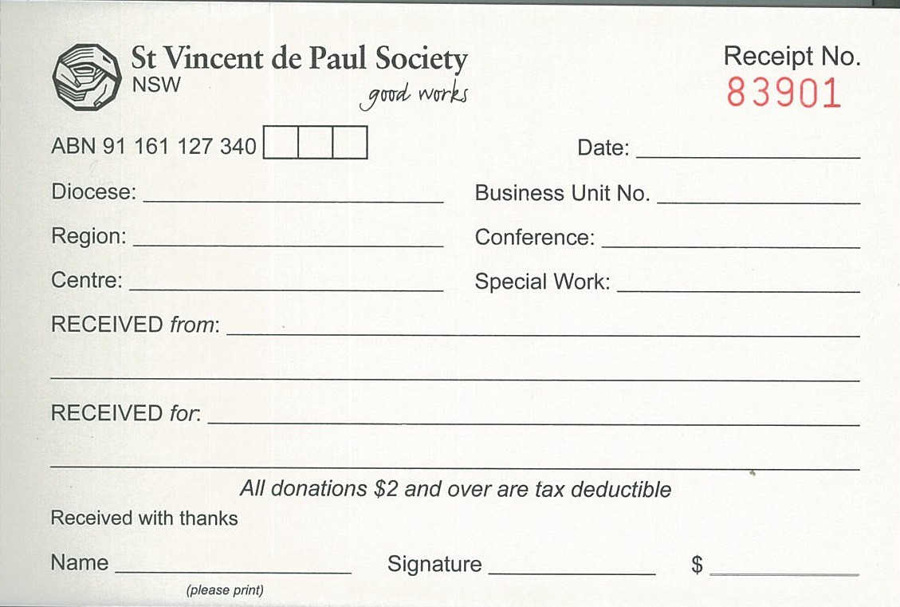

*Bathurst Hawkesbury*

*31.5.2017*

*05 465*

*Jordan Springs*

Conference Code

*Tyrone Lancaster*

*20 Winter Drive, Castleleigh NSW 2700*

*Donation – Winter Appeal*

Bob Brown

*Bob Brown*

*500.00*

* 1. A request can be made to have these receipts issued to the donors by the Regional Support Coordinator after their donations are processed.
     1. **Issuing an Interim tax-deductible receipt**
  2. An interim tax-deductible receipt can be issued to the donor by the responsible person if **required for cheque or credit card donations while waiting for the transaction to be validated** and processed by the Regional Support Coordinator. The word ‘Interim Receipt’ however should be clearly written on the receipt along with other required information.



*Interim Receipt*

*8.5.2017*

*Lismore 05 465*

*Hawkesbury Jordan Springs*

*Shirley Dresser*

*2605 Panorama Circuit, North Beach NSW 2867 Donation*

Bob Brown

*Bob Brown*

*90.00*

* + 1. **Handling of credit card donations**
  1. All credit card donation slips should be completed in ink and are processed by Regional Support Coordinator. Credit card slips are to be dropped into the local regional office for processing.
  2. Credit card transactions will be processed by Regional Support Coordinator and credited to the Conference where the donation was received.
  3. The Regional Support Coordinator will notify you when the donations have been successfully processed so you can issue the receipt.
  4. Please refer to the privacy and confidentiality policy about the handling and storing of client credit card details.
     1. **Electronic Donations**

Donations can be made electronically via our Website – [www.vinnies.org.au](http://www.vinnies.org.au)

The donor can nominate the conference that they would like the donation to go. A receipt is automatically generated based on the information supplied through the website.

Otherwise, they can transfer the funds to

ST Vincent de Paul Society NSW

BSB 062-193

Account 10057471

Reference Conference Code (you will need to supply to them)

They will need to email details to [rsc@vinnies.org.au](mailto:rsc@vinnies.org.au) to enable the issuing of a receipt.

###### Cash handling

* Should be counted by two people wherever possible – Refer Cash Handling Policy
* Should be deposited promptly to the bank using your Society allocated deposit book
* Ideally where there are larger sums of money two people should go together
* Conference funds should always be stored securely and separately to personal funds
* Store cards should be treated as cash as they are highly negotiable.

For future details refer to the Society’s Cash Handling Policy

1. **Expenses**

**All** expenses must be properly authorized and accounted for to ensure that the financial stewardship of the Society is transparent and compliant with the current legislation.

###### Type of expenses

There are basically four types of expenses/payments that relate to Conference work and they are listed below. Details of these expenses and their related account codes are shown in the **Chart of Accounts – refer Appendix 6**

1. **Client Support Expenses** are payments that are made directly to or for those we assist with items such as food, medical, clothing, furniture, whitegoods and for assisting with payments for accommodation, relocation, transport, and utilities.
2. **Volunteer Expenses** include any expenses that are incurred for volunteers who assist the Society in carrying out its missions, for example transport & training costs – refer Volunteer Reimbursement Policy**.**
3. **Operating Expenses** include any expenses that are incurred in the day to day operations of the Conference such as postage, printing and stationery.
4. **Other Costs** include any expenses that are not listed above, for example twinning accounts.

###### How payments are made

All Conference expenses/payments are paid by Finance except incidental expenses (less than $50.00) which can be paid by petty cash if a conference has access to petty cash. A request for payment to be made to a third party is done through a Payment Voucher **(Refer page 15 for Sample form filled in )** which must be supported by invoices and/or supporting documents and approvals should be sought in accordance with the Financial Delegations. **(Refer page 6)**

For Store Cards and Vouchers refer Gift Card Policy.

**Gift Card Order Form (Refer page 16)**

The most commonly used methods of payments are EFT or BPAY

* + 1. **Expenses paid by EFT**
       1. A Payment Voucher, **(refer page 15),** should be completed to request a payment to be made to a third party, for example payment to a real estate agent for the payment of rent to those we assist.
       2. Attach invoices and or supporting documents with the completed and approved Payment Voucher.
       3. Finance office cannot process payments that are not properly approved as per the members delegation schedule
       4. These forms can be emailed to [Accounts.Payable@vinnies.org.au](mailto:Accounts.Payable@vinnies.org.au), faxed to 02 9641 8397 or mailed to
          - P.O.Box 5 Petersham , NSW 2049.
       5. On receipt of the completed and approved Payment Voucher, Finance will make payments promptly.



Email: Accounts.Payable@Vinnies.org.au /Fax (02) 96418397

or post to

P.O.Box 5 , Petersham, NSW, 2049

Attention: Accounts

Payment Voucher (Sample)

|  |  |  |  |
| --- | --- | --- | --- |
|  |  |  |  |
| Date | 27.5.2017 | | |
| Region | Hawkesbury | | |
| Conference Code | 05 465 | Name | Jordan Springs |
| Description of Expense  Payment of Client’s Rent  Does the person seeking assistance need this urgently? (Brief explanation)  Client has received an eviction notice | | | |
| Payee | Ray White Real Estate | | |
| ABN | 91 659 647 641 | | |
| Address | 987 Smith Street St Marys | | |

|  |  |  |
| --- | --- | --- |
| Account Code | | $ Value |
| Client Expenses Accommodation 2135 | | $800.00 |
|  | |  |
|  | | |
| EFT Details |  | |

|  |  |  |
| --- | --- | --- |
| Approval Signature | Name | Position |
| Bob Brown | Bob Brown | Treasurer |
| *Agreed at Conference meeting on the 14th of May 2021* |  |  |
|  |  |  |

**To be signed off in line with the current delegations of authority for members.**

____________________________________________________________________________________________

Email: RSC@vinnies.org.au

Or contact your local

Regional Support Coordinator



Order No. ___________/______

Office Use Only

Please note that it can take up to 12 days

for the supply of this order to reach you.

**Gift Card Order Form**

|  |  |  |  |
| --- | --- | --- | --- |
| Date |  | | |
| Region |  | | |
| Conference Name |  | Code |  |

|  |  |  |  |  |
| --- | --- | --- | --- | --- |
| **Provider** | **Type of Card  ie Grocery Only** | **Card Value** | **Number of Cards** | **$ Value** |
|  |  |  |  |  |
|  |  |  |  |  |
|  |  |  |  |  |
|  |  |  |  |  |
|  |  |  |  |  |
|  |  |  |  |  |
|  |  |  |  |  |
|  |  |  |  |  |
|  |  |  |  |  |
|  |  |  |  |  |
|  |  |  |  |  |
|  | |  | **Total** | **$** |

|  |  |  |  |
| --- | --- | --- | --- |
| Contact Name: |  | Contact Number: |  |

Preferred method of supply (please select one): Pick up  Delivery

|  |
| --- |
| Delivery address: |
|  |

|  |  |  |
| --- | --- | --- |
| **Approval Signature** | **Name** | **Position** |
|  |  |  |
|  |  |  |

**To be signed off inline with the current delegations of authority for members and conference budgets.Please email or post your gift card order and completed gift card register for previous order to your Regional Support Coordinator.**

* + 1. **Expenses paid by Petty Cash**
       1. Petty cash is used for incidental expenses that are below $50.00 and a Petty Cash Voucher should be used to record those expenses.
       2. Petty cash vouchers books can be purchased from local supplier.
       3. The voucher should be supported by a receipt and signed off by the responsible person or issuer.
       4. If a receipt is unobtainable or lost, signature of the receiver or requester for the cash should be sought.
       5. When the petty cash is running low, a Petty Cash Reimbursement Form **(refer page 18)** should be filled out by the responsible person requesting replenishment of petty cash that was used.
       6. This completed form should be supported by all Petty Cash Vouchers and emailed to [Accounts.Payable@vinnies.org.au](mailto:Accounts.Payable@vinnies.org.au), faxed to 02 9641 8397 or posted to PO Box 5, Lewisham NSW 2049, for processing.
       7. Petty Cash cheques are sent out by registered mail and on receipt should be promptly cashed out at a Commonwealth Bank.
       8. Cash needs to be stored safely and access should be limited to the responsible person only.

3.2.3 **Petty Cash Debit Cards for conference members**

(NB Procedure and forms to be inserted when system has been rolled out following pilot expected to be completed by end of April 2021)

3.2.4 **Society Corporate Cards**

These are available for Regional and Central Council Presidents to assist with urgent payments for conferences. Please contact your local Regional Support Coordinator to organize for a card.



Email:[Accounts.Payables@vinnies.org.au](mailto:Accounts.Payables@vinnies.org.au)

or post to

P.O.Box 5 , Petersham,nsw , 2049

Attention Accounts

**Petty Cash Reimbursement Form**

|  |  |  |  |
| --- | --- | --- | --- |
| Date |  | | |
| Region |  | | |
| Conference Name |  | Conf. Code |  |

|  |  |  |  |  |
| --- | --- | --- | --- | --- |
| **Voucher Number** | **Account Code** | | **Date** | **Amount $** |
|  |  | |  |  |
|  |  | |  |  |
|  |  | |  |  |
|  |  | |  |  |
|  |  | |  |  |
|  |  | |  |  |
|  |  | |  |  |
|  |  | |  |  |
|  |  | |  |  |
|  |  | |  |  |
|  |  | |  |  |
|  |  | |  |  |
|  |  | |  |  |
|  | | **Amount to be reimbursed** | | **$** |

|  |  |  |  |
| --- | --- | --- | --- |
| Contact Name: |  | Contact Number: |  |
| Address cheque will be posted to: | | | |
|  | | | |

|  |  |  |
| --- | --- | --- |
| **Approval Signature** | **Name** | **Position** |
|  |  |  |
|  |  |  |

**To be signed off inline with the current delegations of authority for members**

1. **Financial Statements**

The Financial Statements are a formal record of the financial activities of the Society.

The financial statements report on income, expenses, surplus or deficit over a period of time. Currently financial statements for Conferences are issued by Finance office on a monthly basis which contains the Profit and Loss Statement.

The Profit and Loss statement shows all financial activities for the month and year to date for the Conference which is compared to budget.

The Financial Statements are sent to Conferences normally on the second (2) week of the month for the preceding month and are available in both hard and soft copy. Please review and share with your conference members.

Conference Treasurers should provide a regular report to members about income and expenses/payments; this can be done from the local records as an interim report until the reports are provided by the RSC.

If you have any questions, please email your Regional Support Coordinator at RSC@vinnies.org.au

Refer **appendix 4** for sample of Conference report

1. **Frequently Asked Questions (FAQ)**
2. **What if I run out of Deposit Book, Receipt Book and Forms?**

Deposit Books and Receipt Books can be ordered through Regional Support Coordinator. Please allow ample time as they are ordered from external suppliers. Forms can be photocopied for future use or, if requested, they can be sent out as hard copy from your Regional Support Coordinator.

1. **How do I account for donations collected from the poor box?**

From an internal control perspective and providing protection to members who are handling cash, it is recommended that cash donations are counted and signed off by two (2) members.

1. **Can I issue a Tax Deductible receipt for cheque or credit card donations?**

As cheques and credit cards need to go through a clearance process with banks or financial institutions, it is recommended that Tax Deductible Receipts can only be issued after the financial transactions are validated, cleared and processed. Conferences can issue Interim Tax-Deductible Receipts.

1. **What do I need to send to the Regional Support Coordinator at month end?**

Deposit Notification Forms are sent to Regional Support Coordinator to confirm to what account the money banked should be credited.

1. **Who signs a Payment Voucher and what are the requirements**
   * **All Client support expenses should be made after agreement of at least 2 conference members**
   * Up to $750 - two Conference Members
   * From $751 to $1,000 -Conference Member and Conference President
   * From $1501 to $2,500 – Conference Treasurer and Conference President
   * From $2,501 to $5,000 – Conference Treasurer and Conference President and Regional President
   * Over $5,000 – Central Council President and State Council President
2. **Is there a preferred method for payment s?**

Electronic Funds Transfer (EFT) is preferred but payments can also be made through BPay.

1. **How often should I replenish our Petty Cash?**

As often as it is needed but please allow ample time for Finance office to process requests as every single petty cash voucher must be processed for GST compliance purposes

1. **How often should I stock up on store cards and vouchers?**

As often as it is needed. Depending on pattern of usage, which is varied from one Conference to another, it is recommended that store cards and vouchers are to be stocked up before they run out. However, as store cards are deemed as cash, always consider risks involved on receiving and storing these cards. If the risks are an issue, consider ordering small parcels instead of a full order when stocking up. To order store card please email [RSC@vinnies.org.au](mailto:RSC@vinnies.org.au).

1. **Can I authorise my own expenses or those of a family member?**

The person who incurs the expense or authorises an expense should not be the person who approves the transaction. As a golden rule, no one should approve their own expenses or that of family members’ expenses.

1. **What happens if I submit payment requests to Finance office without proper supporting documents or transactions are unauthorised or not properly authorised in accordance with the financial delegations?**

It will delay the process of getting expenses paid as Finance office will ask for the payment requests to be re-submitted with correct supporting paperwork

1. **What do I need to do if a receipt or supporting document is lost/misplaced or unobtainable for our expense claims?**

A brief explanation is required on petty cash voucher or payment voucher stating the reason

1. **How does Twinning account work and do I need to do anything?**

Conferences can financially support conference works in developing countries through twinning arrangements. State Office will send CC an invoice each quarter and payments are made from CC directly to State Office who will in turn forward payments to National Office for distribution to the overseas country. Payments made to twin conferences are recorded on the Conference Profit and Loss statement. Enquiries from Conferences on Twinning arrangements whether new or existing can be done through the CC Twinning Representative.

1. **What do I need to do at financial year end?**

Year-end stock takes for store cards and petty cash are to be conducted where applicable. Regional Support Coordinators will send out stock take forms and instructions on how these should be done prior to year- end to ensure Society assets are correctly accounted for from a compliance perspective.

1. **What do I do with financial records?**

Financial records in accordance with the Corporations Act 2001 must be kept for seven (7) years after the transactions were completed. Please note where documents have been sent to the Finance Office, Conferences are not required to keep the hard copy as a copy is kept electronically by Finance. The Society’s Record Retention Policy that also includes guidelines for archiving, destruction and deletion of records can be found in **Appendix 2.**

1. **Additional Information**

Below are relevant policies and procedures that are currently in place and can be used to assist in the day-to-day financial operations for Conferences. These policies can be accessed from the MAVS [website](https://mavs.vinnies.org.au/policies/)(https:/mavs.vinnies.org.au/policies) or a copy can be requested from your Regional Support Coordinator.

Cash Handling Policy

Gift Card Policy

Record Retention Policy

Volunteers Policy

Delegation of Authority Policy

1. **Postal Address For your Regional Support Coordinator**
   1. North East –-P.O.BOX 660 , Lismore ,NSW 2480
   2. North West- P.O.BOX 997, Parkes , NSW 2870
   3. Metropolitan – 32-36 Hampstead Road Auburn, NSW 2114
   4. South- P.O.BOX 356, Wagga Wagga, 2650
   5. West -P.O.BOX 997, Parkes , NSW 2870

(Please mark it to the attention of Regional Support Coordinator)

**Finance Key Performance Indicator’s (KPIs) / Service Level Agreement’s (SLAs)**

**General Communication**

* Emails sent to finance staff members or shared mailboxes to be answered or acknowledged (with an estimated time to get a resolution where possible) within **2 working days** of receipt
* Emails or requests marked urgent to be responded **same day or within requested timeframe/deadline**
* Missed Phone and Teams calls to be returned within **1 working day** of receipt

**Transaction Processing**

* Donations processed and CRM updated within **5 workings days** of date of receipt
* Standard Conference Client Support payments to be processed and paid in the **following payment run (Tuesday or Thursday)**
* Urgent Client Support and other payments to be processed and paid by **corporate credit or debit card**
* Rent Payments to be processed on the **1st working day of each month (WD1)**
* Gift cards to be delivered within **12 working days of receiving approved request**
  + Coles
  + Woolworth
  + Others
* Corporate Cards to be delivered within **12 working days of receiving request**
* Receipt Books to be delivered **10 working days of receiving request**
* Other Accounts Payable invoices to be processed and paid within **agreed supplier payment terms**
* Urgent invoices and payments that are exceptions and cannot be paid by corporate credit/debit card to be processed and paid **same day** assessed on a case by case basis
* Payment runs to be processed on a weekly basis as follows:
  + Tuesday
  + Thursday
  + Urgent payment runs outside of above on a case by case assessment
* Transactions to be posted in line with ‘Finance Materiality Limits’ which is included later in document

**Monthly Reporting**

* Snapshot/Flash of monthly financial result to CEO on **WD7** following close of ledger **WD6** from November month-end
* Consolidated monthly management reporting of Society distributed **WD8** from November month-end
* Directorate, Central Council President and Treasurers reporting on **WD8** from November month-end
* Meeting with business partners (Executive Directors, Directors and Regional Directors) by **WD12**.

**APPENDIXES**

1. [Regional Maps](https://mavs.vinnies.org.au/conferences/)
2. Conference Codes



1. [Our Retail Shops](https://www.vinnies.org.au/page/Shops/NSW/)
2. Conference Reports – Sample



1. Chart of Accounts



1. Blank copy of all forms



