Directorate / Department |  |  | Activity/project title
Prepared by |  |  | Site/location
Approved by  Responsible leader/s |  |  | People at risk |  | Residual Risk | Choose an item.
Who was consulted? | Georgina Reid Team Leader |  | Date (initial assessment) |  | Review Date
Reference material  Code of Practice, Aust. Standards |  |  |  |  | Director’s approval – if high or very high |  | o

Risk Identification |  |  |  |  |  | Risk Reduction
Step 1  Task or scenario description | Step 2  What could go wrong? | Step 3  Existing Risk Controls | Step 4  Risk Score |  |  | Step 5  Additional Risk Controls | Step 6  Residual Risk Rating
 |  |  | Consequence | Likelihood | Risk Score |  | Consequence | Likelihood | Risk Rating
 | r |  |  | Choose an item. | Choose an item. |  | Choose an item. | Choose an item. | Choose an item.
 |  |  | Choose an item. | Choose an item. | Choose an item. |  | Choose an item. | Choose an item. | Choose an item.

Emergency response
How will you respond to an incident if it occurs during this activity? This might include an equipment breakdown, fire, spill, extreme of unpredictable response of a person we assist, or another situation that means you need to suddenly stop this activity.

Implementation of additional risk controls

Additional risk controls required | Resources required | Person responsible | When by | Completed
 |  |  |  | ☐
 |  |  |  | ☐
 |  |  |  | ☐
 |  |  |  | ☐

Review
 | 12 Months | 24 Months | 36 Months | 48 Months
Agreed risk controls are in place? | ☐ | ☐ | ☐ | ☐
Agreed risk controls are effective? | ☐ | ☐ | ☐ | ☐
Review comments
Reviewed by:
Date of review

Risk Management Methodology
Identifying and assessing risk | Hierarchy of risk controls
Assessing the risk associated with a task, activity or new project is a brainstorming and problem-solving activity most effectively conducted in a team environment involving the people required to complete the task or activity. Most activities can be broken down into several separate tasks or steps. In other situations, we may need to consider multiple scenarios. For each task step or scenario, consider the hazards involved, the potential harm (or negative outcomes) and the conditions required for those negative outcomes to occur.  Whenever assessing the health and safety risks associated with an activity consider a range of risk factors including the:  - Physical activities required to complete the task (e.g., repetitive movement, high force, physical exertion, awkward posture)  - Work environment (e.g., lighting, layout, traffic flow, ventilation, access to support if something goes wrong)  - Nature of the hazards involved (e.g., mobile plant and equipment, electricity, infectious diseases, aggression, or workplace violence)  - People involved (e.g., the level of training, experience, supervision, health status, age, and physical capacity)  - Potential psychological impact of the work on the individuals (e.g., level of work demand/control, potential for direct or vicarious trauma).  Use the risk matrix on the following page to determine a qualitative risk rating for each step in the process by considering the most plausible consequences and the likelihood that those events will occur. You need to consider the separate risk ratings of each task/step to determine the overall risk rating. | If there is a risk to health and safety, we have an obligation to consider whether the risk can be eliminated altogether before considering alternate risk controls to minimise the risks so far as is reasonably practicable. Some risk controls are more effective than others.  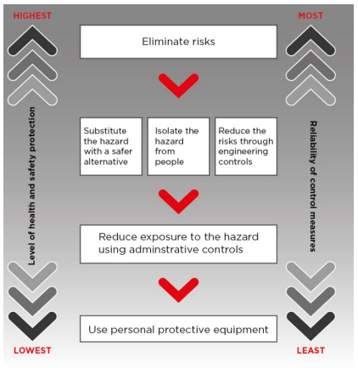

Risk Matrix
Likelihood | Consequence
 | Slight  Minor injuries or physical discomfort.  Short-term psychological impact (isolated or one off). | Minor  Injury or illness requiring medical treatment and/or short-term impairment (less than 2-weeks).  Psychological impact requiring support. | Moderate  Injury or illness requiring hospital admission and of temporary impairment (<6 months).  Psychological impact requiring medical treatment. | Major  Injury or illness (physical or psychological) resulting in long-term or permanent impairment. | Extreme  One or more fatalities.
Almost Certain  Expected to occur regularly under normal circumstances. | MEDIUM | HIGH | HIGH | VERY HIGH | VERY HIGH
Likely  Expected to occur at some time. Strong probability. | LOW | MEDIUM | HIGH | VERY HIGH | VERY HIGH
Possible  May occur at some time, may have happened before. | LOW | MEDIUM | MEDIUM | HIGH | VERY HIGH
Unlikely  Not likely to occur in normal circumstances. | VERY LOW | LOW | MEDIUM | MEDIUM | HIGH
Rare  Will only occur in highly exceptional circumstances. Not expected to occur. | VERY LOW | VERY LOW | LOW | MEDIUM | HIGH

References: SafeWork NSW Code of Practice: How to manage work health and safety risks May 2019
St Vincent de Paul Society NSW: Risk Management Framework

